Login the system using admin user

Register new system user

Delete existing system user

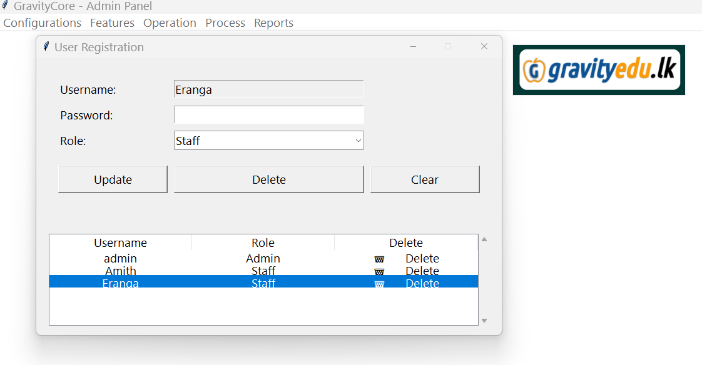

Do the class registration

Do the deletion for existing class registration

Do the student registration

Do the teachers registration

Update existing teacher record

Do the class schedule registration

Delete existing class schedule record

Do the student enrollment for class

Do the student class fee payment entry

Verified the class fee payment

Check whether system allows duplicate payment

